Week 10

Comprehensive Application Development, Integration and Testing.

Integration

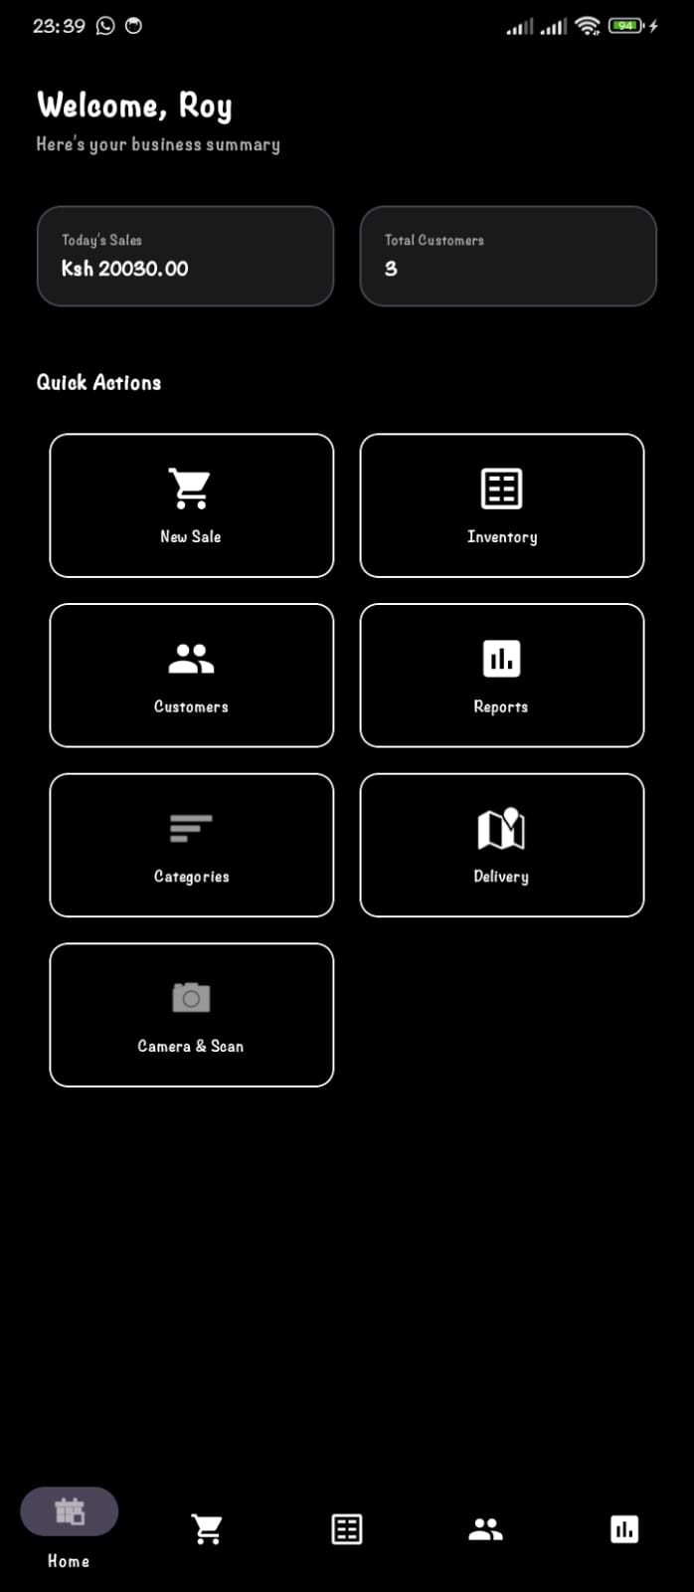

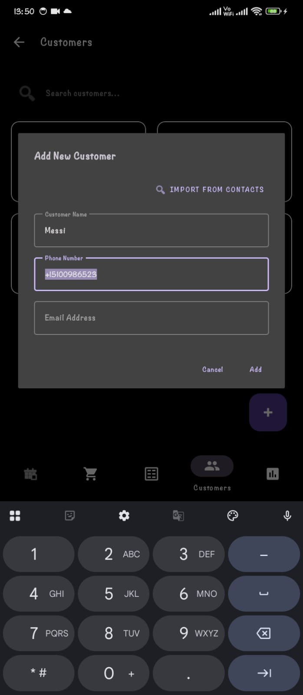
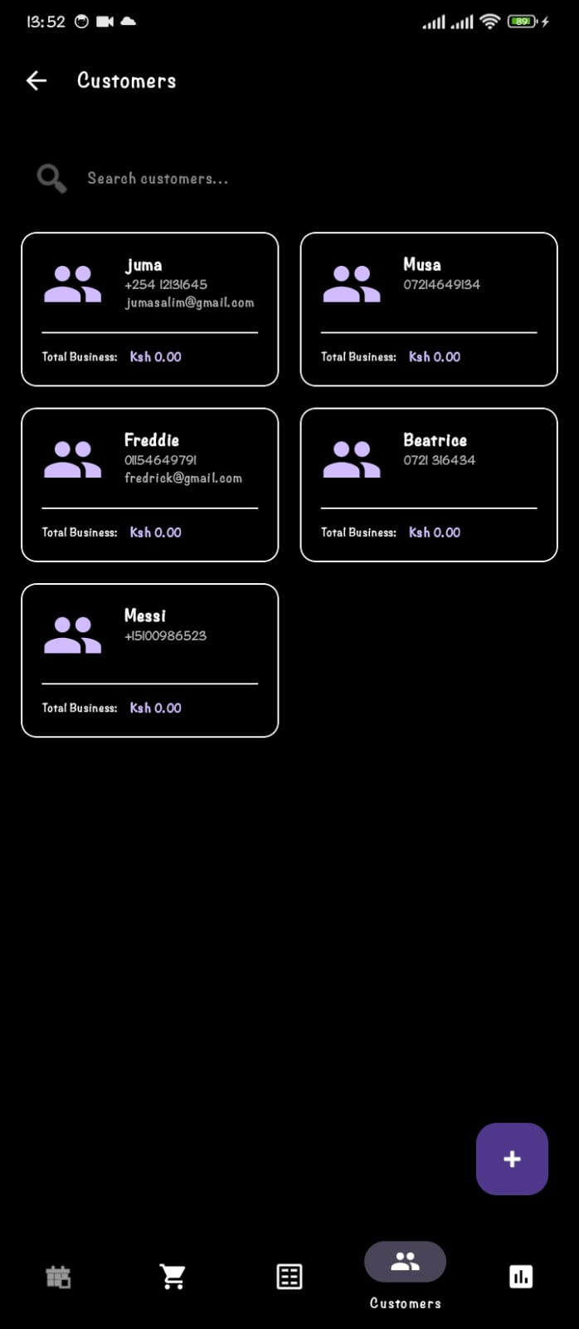
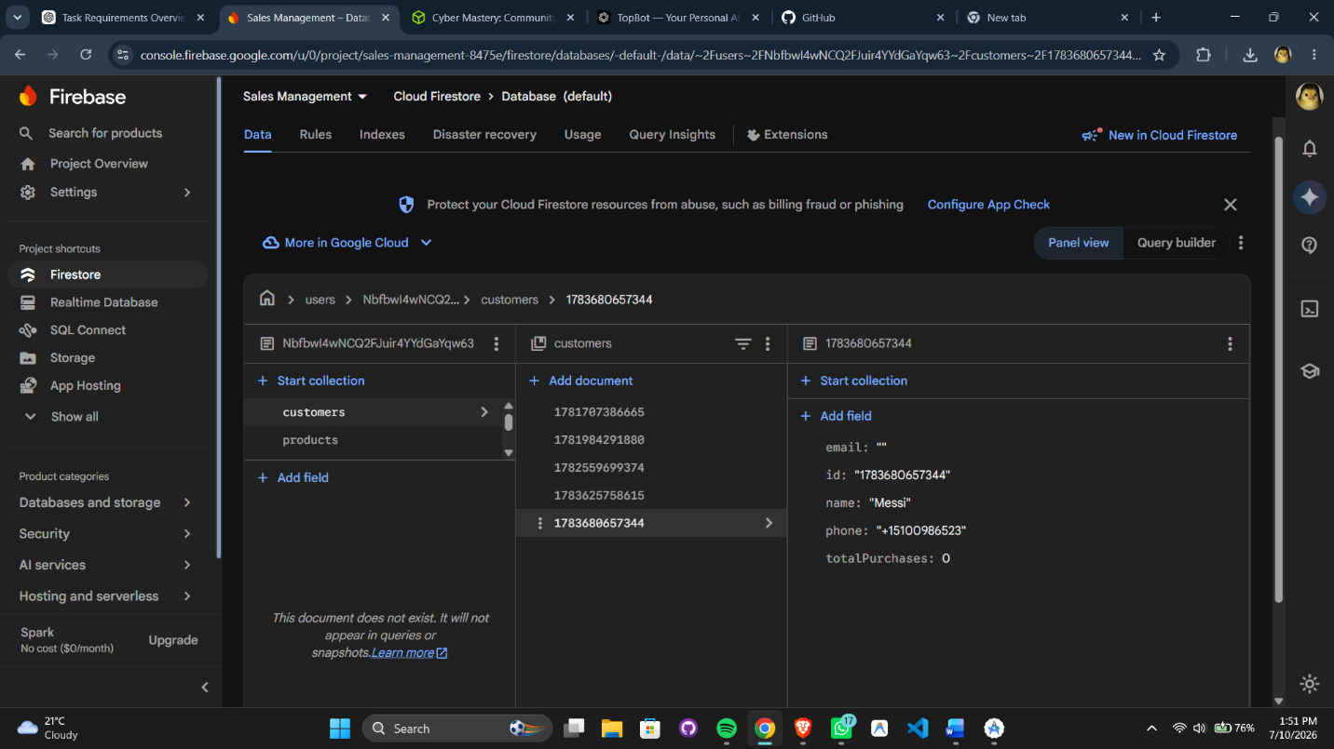

Debug the application
By accessing the New sales feature on the Dash Board, we are able to see the transaction activity based on real time interaction.

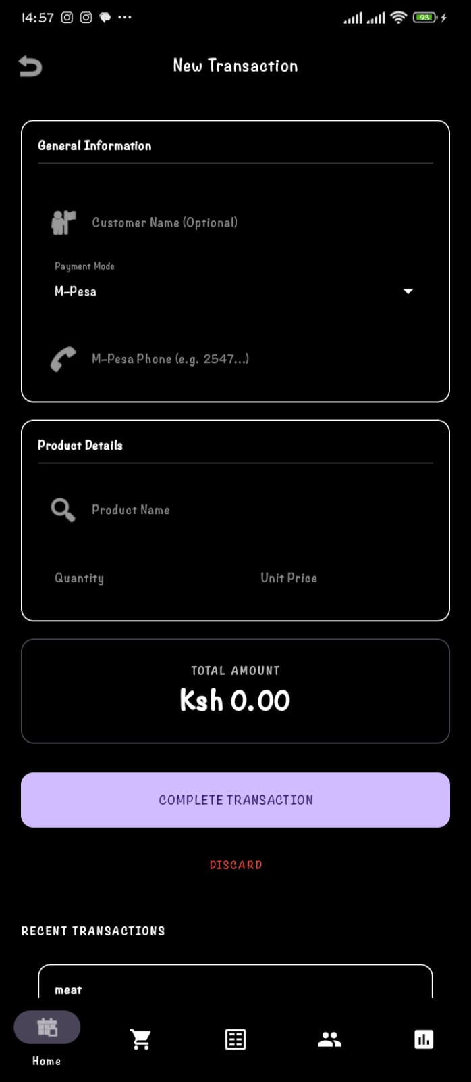

Here is a practical Demo of the realtime DataBase by use of the Logcat which collect, view, and analyze real-time system and application log messages.
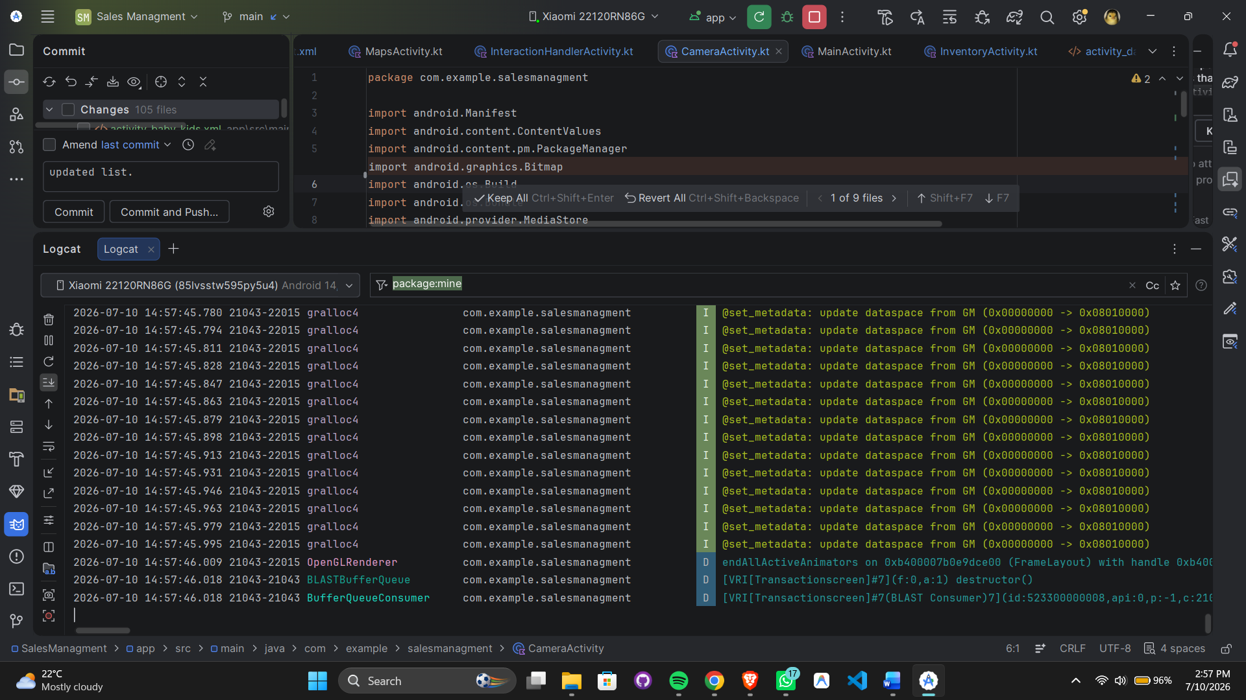

App features.
In the sales report , data and information is collected and analysed by use of a graph indicating stock levels and sales deployment.
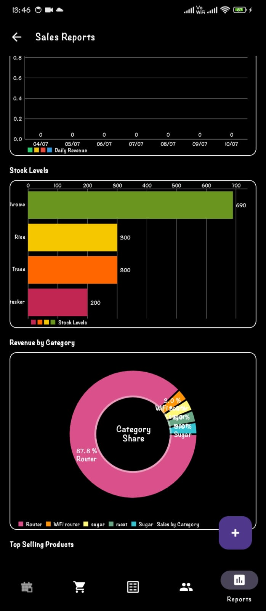

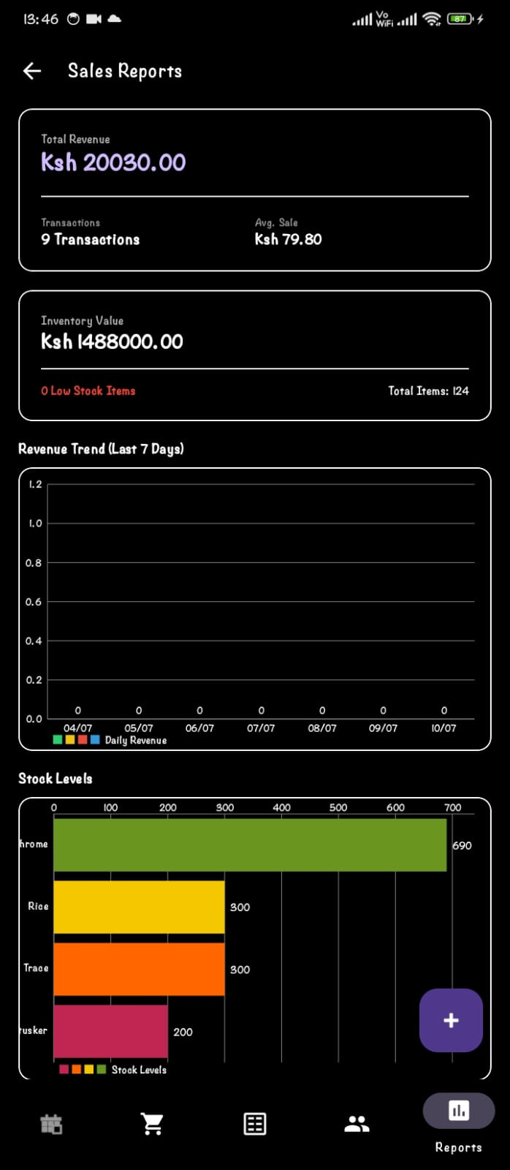

User Guide –Sales Management Android Application.
Introduction
The Sales Management Android Application is a mobile solution designed to help users manage sales activities anytime and anywhere. The application enables users to record sales transactions, manage customer and product information, monitor inventory, and generate sales reports through an easy-to-use interface.
System Requirements
- Android 8.0 +
- At least 2 GB RAM
- Internet connection (if using cloud/database synchronization)
- User account with valid login credentials
Getting Started
- Install the Sales Management App on your Android device.
- Open the application by tapping the app icon.
- Enter your Username and Password.
- Tap Login to access the dashboard.
- If you are a new user, register an account if the application supports user registration.
Using the Application
Dashboard
The dashboard provides quick access to all major functions, including Products, Customers, Sales, Inventory, and Reports.
Product Management
- Add new products.
- Update product information.
- Delete products.
- View available stock levels.
Customer Management
- Register new customers.
- Edit customer details.
- Search for customers by name or phone number.
Sales Transactions
- Create a new sale.
- Select the customer and product(s).
- Enter the quantity.
- The application automatically calculates the total amount.
- Save the transaction to update sales records.
Reports
- View daily, weekly, or monthly sales summaries.
- Monitor sales performance.
- Review transaction history.
Logging Out
To secure your account, tap the Menu icon and select Logout when you have finished using the application.
Troubleshooting
- Cannot log in: Verify your username and password or reset your password if necessary.
- Application not loading: Check your internet connection and restart the application.
- Unable to save data: Ensure all required fields are completed and that your device has network connectivity if online synchronization is required.
Best Practices
- Keep your login credentials secure.
- Update product and customer information regularly.
- Synchronize your data whenever an internet connection is available.
- Always log out after using the application, especially on shared devices.
Support
For assistance, contact the system administrator or application developer. Report any bugs or technical issues to ensure timely maintenance and system improvements.

Sales Management Android Application Overview
1. Purpose of the Application
The Sales Management Android Application is designed to simplify and automate the management of sales activities for businesses. It enables users to record sales transactions, manage customer and product information, monitor inventory, and generate sales reports using a mobile device. The application improves accuracy, reduces paperwork, saves time, and supports informed business decision-making through real-time access to sales data.
2. Key Features
- Secure user login and authentication.
- Dashboard displaying an overview of sales activities.
- Product management (add, edit, delete, and view products).
- Customer management (register, update, and search customers).
- Sales transaction recording with automatic total calculation.
- Inventory management with stock updates after each sale.
- Sales history and reporting for tracking business performance.
- Search functionality for products, customers, and sales records.
- User-friendly Android interface for easy navigation.
3. Target Users
The application is intended for:
- Small and medium-sized business owners.
- Retail shop owners.
- Sales representatives.
- Store managers.
- Cashiers and sales clerks.
- Entrepreneurs who require a simple mobile solution for managing daily sales operations.
4. Future Enhancements
Future versions of the application may include:
- Push notifications for low-stock alerts and sales reminders.
- Advanced analytics with interactive charts and business insights.
- Multi-user access with role-based permissions (Administrator, Manager, and Salesperson).
- Receipt generation and Bluetooth printer support.
- Offline mode with automatic synchronization when internet connectivity is restored.
- Export of sales reports to PDF and Excel formats.
- Integration with accounting and enterprise resource planning (ERP) systems.

